**West Virginia Chess Association**

presents

**Mike Price**

**Memorial Chess Tournament**

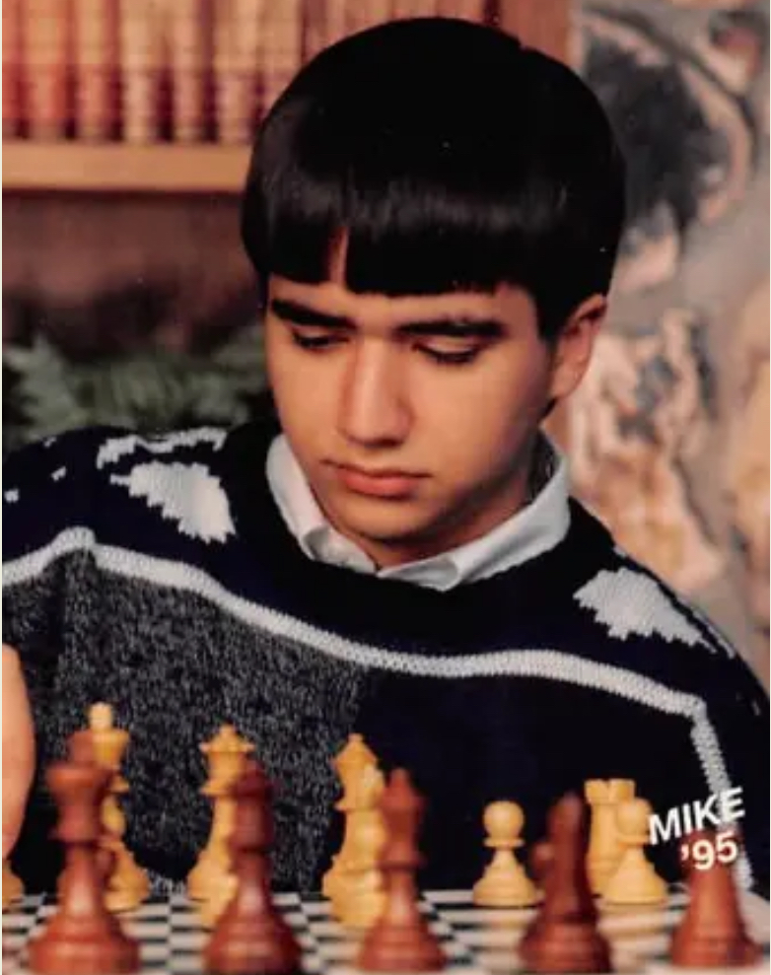

To be held **July 19, 2025** at the historic

**Blennerhassett Hotel**

320 Market Street, Parkersburg, WV 26101

**Format**: 4 Round Swiss System, G/60 d5

**Registration**: 9-9:45 am

**Rounds**: 10am-1pm-3:15pm-5:30pm

**Entry Fee**: $25

**Prizes**: $120 for 4 points, $60 for 3.5 points, $40 for 3 points, $25 for 2.5 points.

Tournament will be held in the Alexander Parker room. Beverages will be provided. US Chess membership required (available on-site). **Please bring sets and clocks**.

**Mail entries**: Send $25 to WVCA, 444 Ashberry Drive, Flemington, WV 26347. Make checks payable to WVCA. Include full name and USCF ID.

**Online entries:** Visit chessregister.com, search for Mike Price Memorial.